**Crop-Weed Relationship Studies in Additive Design: Selecting the Best Empirical Model**

Maxwel Coura Oliveira1, Rodrigo Werle2, Gustavo Antônio Mendes Pereira3

1University of Nebraska-Lincoln, Department of Agronomy and Horticulture, Concord, NE 68728 - United States of America

2University of Nebraska-Lincoln, Department of Agronomy and Horticulture, North Platte, NE 69101 - United States of America

3Federal University of Viçosa, Department of Phytotechnic, Viçosa, MG - Brazil

*Corresponding author <moliveira@huskers.unl.edu>

Category: Biometry, Modeling, and Statistics.

**Abstract**:

**Keywords**: AIC, Competition, Maize, *C. benghalensis*, *R. brasiliensis*

**Introduction**

Many studies have described the relationship of crop yield in function of weed density in additive design. In a literature review, there is no common sense of which is the most appropriate model, data sets are fitted with several different curves (Meyers et al. 2010; Monquero et al. 2015; Silva et al. 2015; Strieder et al. 2007; Voll et al. 2002). Four major regressions curves are used: linear (Figure 1A), polynomial quadratic (Figure 1B), sigmoid (Figure 1C), and rectangular hyperbola (Figure 1D).

The general criteria accepted for model selection of nonlinear regression model is the equation with higher R-squared (R2). However, R2 tests the goodness of fit and it is statistically not recommended for nonlinear model selection (Archontoulis and Miguez 2015; Zuur et al. 2007). There are several appropriate statistical criteria for selecting the best nonlinear model for data sets: Alkaike’s information criterion (AIC), Bayesian information criterion (BIC), F-test, and likelihood ratio (Anderson 2008; Lewis et al. 2011; Zucchini 2000). For non-nested (different structure) models AIC and BIC are indicated for model selection. But for nested model (models is a special case of another), F-test or any of the model selection described above are applicable. From the practical standpoint, the model should be selected in a balance of statistics and the best model that will answer the research question (Archontoulis and Miguez 2015). Therefore, in crop-weed studies in additive design, the model that provides good fit and meaningful biological parameters is a strong candidate model.

Weeds compete for resources (water, nutrients, and light), limiting crop yield and reducing crop quality (Zindahl, 2014). The economical weed control decision making depends on the weed density that is likely to reduce crop yield. Hence, crop-weed models are essential for this economic analysis. Here, we compare statistically and biologically three candidate models (polynomial quadratic, logistic, and Cousens) for fitting crop-weed relationship data sets. We will use a real experiment of maize (*Zea mays* L.) in competition to two weed species, *Richardia brasiliensis* and *Commelina benghalensis*. After showing the best model to fit our data set, we will test the hypothesis that *C. benghalensis* and *R. brasiliensis* compete similarly or not in maize.

**Material and Methods**

*Planta Material*. On March 2011, inflorescences of *R. brasiliensis* was harvest on roadsides near Diamantina, MG. Inflorescences of *R. brasiliensis* was dried at room temperature (25 °C), cleaned, and stored at 5 °C until the start of the experiment. Several days before the experiment begin on August 2011, stolon (vegetative propagules) of *C. benghalensis* was collected in wetlands, near Diamantina, MG. Seeds of *R. brasiliensis* and stolon of *C. benghalensis* were seeded and transplanted to separated trays (1210 cm3) filled with red latosol (pH 6.1 and 1% organic matter). Glyphosate-resistant (GR) maize (AG8088) seed was sow in 8 dm3 plastic pots filled with the identical soil described above. Soil was fertilized following the local recommendations and N was applied at 15 and 30 DAE (days after maize emergence) at a rate of 55 mg dm-3 of ammonium sulfate. Greenhouse conditions was 26/19 °C day/night and pots were supplied with adequate water.

*Experimental procedures*. The experiment was conducted in greenhouse conditions at the Federal University of Jequitinhonha and Mucuri, MG. In this study, the additive design for competition studies was used, which weed densities vary and maize is kept constant, this is the most realistic design for CWRAD (Swanton et al. 2015). The treatment design was factorial with two weed species, *R. brasiliensis* and *C. benghalensis* (0, 1, 2, 3, and 4 plants pot-1), in a completely randomized design with four replications.

Maize biomass was harvested at 60 DAE from each experimental unit. Maize root was cleaned by emerging into water and using a water pressure hose (25 psi). Shoot and root biomass were oven-dried at 65 °C until reaching constant weight, so weight of biomass was recorded. The maize biomass (g) data (shoot and root) were converted into biomass reduction (%) compared with the nontreated experimental unit as:

$Maize Biomass Reduction (\%)=\frac{M-B}{B}*100$ eq. (1)

where *Μ* is the mean biomass (g) of the nontreated experimental unit replicates, and $B$ is the biomass (g) of an individual treated experimental unit.

**Statistical Analysis**

Three models were fitted to the maize biomass reduction (%) data set:

*Rectangular hyperbola model*. The rectangular hyperbola proposed by (Cousens 1985) was fitted to the data:

$YL=\frac{ID}{1+\left(\frac{I}{A}\right)D}$ eq. (2)

where *D* represents the density of the weedy species (plants pot-1), I represents YL per unit weed density as D approaches 0, and A represents YL as D approaches ∞ (or maximum expected yield loss). The Cousens model was fitted using *nls* function of R version 3.3.1 (R Foundation for Statistical Computing, Vienna, Austria).

*Sigmoid model.* The sigmoid model (four parameter log-logistic curve) was used to fit the data:

$YL=c+\frac{d-c}{1+exp⁡[b(\log{x-\log{e)]}}}$ eq. (3)

In this model, YL is the maize biomass reduction (%), c is the lower limit, d is the asymptote (upper limit), and *e* represents the weed density (weeds pot-2) that cause 50% biomass reduction (inflection point). The parameter *b* is the relative slope around the parameter *e*, and *x* is the number of weeds pot-1.

The sigmoid model (four-parameter logistic) was obtained from a *drm* function of drc package (Ritz and Streibig 2005) in R software.

*Polynomial quadratic model.* A quadratic (second order) polynomial model for a response variable has the form of the equation below:

$YL=α+ax+bx^{2}$ eq. (4)

In this model, *YL* is the maize biomass reduction (%), α is the intercept in the y-axis, a represents the slope of the model. The parameter *b* is quadratic term of the model, and *x* is the number of weeds plot-1. The polynomial quadratic curve was obtained from *lm* function of R software.

***Non-Nested Model Selection Criteria***

Alkaike’s Information Criterion (AIC) was used for selecting among polynomial quadratic, four parameter logistic, and Cousens model for fitting maize biomass reduction (%) data set. AIC is indicated for non-nested model selection. The AIC was calculated according (Anderson 2008) and (Zuur et al. 2007)

$AIC=-2log(l) + 2K$ eq. (5)

where $l$ is the likelihood function and $K$ is the number of estimated parameters in the model. The best model yields the lowest AIC value, the model selected by AIC minimizes the information lost when approximating full reality, which means that it selects the approximating model closest to the unknown reality (Anderson, 2010). AIC values for each model were estimated using AIC command in R software.

***Nested Model Selection Criteria***

In order to evaluate the competitiveness of *R. brasiliensis* and *C. benghalensis* on maize biomass reduction (%), the variance-ratio or F-test was performed using equation 2 (Lindquist et al. 1996). This statistical procedure evaluates the difference of residual sum squares (RSS) of two considered nested models (Werle et al. 2014). In order to compare the parameters using this method, four major steps needs to be completed (see also Table 1 of supplemental file):

1. Fit equation 4 for each data set individually (*R. brasiliensis* and *C. benghalensis*), this would be the full model, where 4 parameters (I and A for each weed species) will be estimated.

2. Pool data across all data sets being compared (*R. brasiliensis* and *C. benghalensis*) and fit equation 4 to the pooled data. This would be a reduced model, where parameter 2 parameters (I and A for both weed species) will be estimated. This step tests the hypothesis that I and A do not vary among data set, which means that both species compete similarly in maize. If hypothesis is accepted, stop here. In contrary, there is two more hypothesis to be tested.

3. Fit equation 4 for each data set separately, setting the parameter I similar to both data set, but different A. This is a reduced model and thee parameters will be estimated. This step tests a second hypothesis, that weed species compete similarly at low densities (I), but different at higher densities (A).

4. Fit equation 4 for each data set separately, setting the parameter A similar to both data set, but different I. This is a reduced model and thee parameters will be estimated. This step tests a third hypothesis, that weed species compete similarly at higher densities (A), but different at higher densities (I).

According to this procedure, the following equation represents the F-test:

$F=\frac{({RSS}_{FULL}-{RSS}_{FULL})/({df}_{RED}-{df}_{FULL})}{{SQR}_{FULL}/{gl}_{FULL}}$ eq. (6)

Where RSSFULL RSSRED represents the minimized residual sum squares of the parameters estimated of the full model (step 1) and reduced model (step 2, or 3, or 4), respectively; dfFULL and dfRED represents the degrees of freedom of full model and reduced models, respectively. Large F-value shows that two models are different, but small F-value shows that two models are similar. The F-value is quantified as a P-value resulted from F-distribution. A P-value >0.05 means that there is no significant difference between models, the null hypothesis is accepted and models are similar; therefore a reduced should be used (no difference of parameters I and/or A among weed species). In contrary, if P-value <0.05 means that there is significant difference between models, the null hypothesis is rejected and that a full model should be used (parameter I and A for each weed species).

Additional AIC was also performed for the nested model selection. The F-test principle for nonlinear regression analysis was calculated for each model using *nls* *ANOVA* command (Ritz and Streibig 2008) of R software.

***Model Goodness of fit*.**

Root mean squared error (RMSE), model efficiency (ME) and R-squared (R2) were calculated and used to test the goodness of fit and indications of model quality (Archontoulis and Miguez 2015; Mayer and Butler 1993; Roman et al. 2000).

$RMSE=\sqrt{\frac{SSresidual}{n-p-1}}$ eq. (7)

eq. (8)

*R2* eq. (9)

where SSresidual SStotal is the sum of squares for the residual and total, respectively; $n$ is the number of data points, $p$ is the number of model parameters. $Oi$ is the observed value, $Pi$ is the predicted and $Ōi$ is the mean observed value. The smaller the RMSE, the observed values are closer to predicted values. In this present study, RSME was an average of *R. brasiliensis* and *C. benghalensis* fitted curves. ME values range from -∞ and 1, with valued closer to 1 indicating more accurate predictions (Werle et al. 2014). R2 values range from 0 to 1 and it was used only for the polynomial quadratic, which is a special case of linear model.

**Results**

***Non-nested model Selection***

Cousens model resulted in the lowest AIC of 268.3, followed by a sigmoid model (271.3) and a polynomial quadratic model (281.8) (Table 1); therefore, the Cousens model was statistically the best model to describe the maize biomass reduction in competition with *R. brasiliensis* and *C. benghalensis* (Figure 2). In addition to AIC, the Cousens model goodness of fit was RSME of was low (6.1) and ME higher, 0.96 and 0.95 for *R. brasiliensis* and *C. benghalensis*, respectively. Four parameter were estimates using Cousens model, parameters I and A for *R. brasiliensis* and *C. benghalensis*, respectively (Table 2). However, there are two issues with the parameter estimates, *A* of *R. brasiliensis* and parameter *I* and *A* of *C. benghalensis* were estimated over 100%. Possibly, *I* was due to the high inclination of the slope of the curve, which might be that at this pot size *C. benghalensis* is very competitive in maize. Moreover, parameter *A* for both species was over 100%, which is an indication that we should use more than four weed densities pot-1. The asymptote was not completely reached using four plants pot-1 in our experiment; therefore *A* was estimated above 100%. We recommend to set weed densities (*X*-value) in logarithm sequence. Despite this common issue, there is no lack of fit of parameters *I* and *A* estimated for *R. brasiliensis* and *C. benghalensis* (P<0.05).

The logistic model (sigmoid curve) provided the second best fit for the data set in this present study (Table 1). Moreover, this model provided the best RSME (5.7), but the lowest ME for *R. brasiliensis* (0.83) and *C. benghalensis* (0.89). This model contain four parameter that have biological interpretation (Table 3). The maximum (*d*) maize biomass reduction caused by the competition of *R. brasiliensis* and *C. benghalensis* was 88.1% and 91%, respectively. The parameter *e* is the weed density (plants pot-1) that caused 50% reduction in maize biomass reduction (%). The parameter *b* is relative to the *d* estimates of each weed species, b was 1.3 and 0.76 plants pot-1 of *R. brasiliensis* and *C. benghalensis*, respectively. The problem of fitting a logistic equation for crop-weed competition study is the systematic parameter *c* lack of fit (Table 3). The P-values for parameter *c* is not significant (P>0.05); therefore this parameter is similar to zero. In addition, the standard error of *c* are way bigger than *c* estimated values, which means that the sample mean is not close to the actual population mean.

The polynomial quadratic model provided the highest AIC (281.8), which means that this model was the least appropriated for fitting our data set (Table 1). Nonetheless, on the basis of ME and R2, this model resulted in a good fit of our data. However, ME and R2 means nothing in terms of model selection. Moreover, this model has a biological implausible turning point (Figure 1B and Figure 4). The parameters estimated for the polynomial quadratic model have no biological meaning in agronomic terms and there is lack of fit for the intercept of *R. brasiliensis* and *C. benghalensis* (P>0.05) (Table 4).

***Nested-model selection***

The rectangular hyperbola proposed by (Cousens 1985) was the best model for fit our data set (Table 1). Thus, we conducted the F-test to select the best model to answer our research question whether *R. brasiliensis* and *C. benghalensis* compete similarly in maize. The F-test of the (Cousens 1985) model for maize biomass reduction (%) indicates that a reduced model (P=0.4864) with different I (competition at low weed densities) and similar A (competition at higher densities) was the best model to describe maize competition to *R. brasiliensis* and *C. benghalensis* (Table 5). According to the parameter estimates in the rectangular hyperbola, at low densities (I), maize biomass reduction was reduced 56.4 and 159.8% in competition to *R. brasiliensis* and *C. benghalensis*, respectively. In contrary, at higher densities, *R. brasiliensis* and *C. benghalensis* compete similarly and maize biomass reduction was 109.5% (Figure 5 and Table 6). Furthermore, the three parameter estimated

AIC corroborates to F-test (Table 5). The model selected by the F-test (different I, but similar A) resulted the lowest AIC of 266.8. The best fit was also demonstrated as this model provides the lowest RSME of 6.1 and the higher ME for *R. brasiliensis* and *C. benghalensis*.

**Discussion**

***Non-nested model Selection***

The rectangular hyperbola proposed by (Cousens 1985) was statistically the best model to described maize biomass reduction (%) in competition to *R. brasiliensis* and *C. benghalensis* (Figure 2) in comparison to polynomial quadratic and logistic models (Table 1). This model was also the best for fitting maize leaf area, height, and stem diameter reduction (data not shown). (Cousens 1985) model provides two biological parameters that are meaningful for crop-weed relationship interpretation and to answer research questions in competition studies, parameter I and A (Table 2).

To understand the biology of crop-weed relationship modeling, there is a need to know the concept of constant final yield (CFY). The CFY definition well revised by (Weiner and Freckleton 2010), these authors describes that from low to hight densities, the relationship between total biomass per unit area and density is initially linear, but eventually reach a constant biomass that does not increase further. Consequently, in crop-weed relationship studies, the concept of CYF is appropriate for the rectangular hyperbola curve (Figure 1D). A competition study that shows a linear relationship trend did not reached the potential CFY (Figure 1A); therefore the appropriated weed density was not selected.

Despite providing biological parameters, logistic model is not suitable for crop-weed relationship studies (Figure 3). The main reason is that this sigmoid curve is symmetric (S-shape) around the parameter *e* (Figure 1C), which the maize biomass reduction (%) or any response (*Y*-value) is forced to zero; therefore, a logistic function assumes that yield loss is close to zero at low weed densities. Though, the logistic model is not recommended for competition studies, it is one of the most used model in weed research, sigmoidal curve is extensively used and it is appropriate for fitting several data sets in weed research, including dose-response, critical time for weed removal, and herbicide metabolism (Knezevic and Datta 2015; Ritz et al. 2015). For example, in dose-response studies, the parameter *e* is meaningful and important for comparison of herbicide doses that control 50% of weed population (Knezevic et al. 2007).

Polynomial quadratic model was statistically the inferior model (highest AIC) to fit the data set in this study (Table 1). In addition, this model does not provide any meaningful biological parameters that would improve the discussion, set hypothesis, and understanding results of crop-weed relationship studies (Figure 4). This curve also is symmetric around its peak, which makes a response (*Y*-value) biologically unlikely in crop-weed studies (Figure 1B). For example, the Figure 4 showed the maximum maize biomass reduction (%) around three plants of *C. benghalensis* pot-1, and then there is a lower response in biomass reduction (%) as increasing *C. benghalensis* density to four plants pot-1. Therefore, a polynomial quadratic curve should be not encouraged to fit regression in competition studies.

***Nested-model selection***

We rejected our hypothesis that *R. brasiliensis* and *C. benghalensis* compete similarly in maize (Table 5). The F-test indicates that competition of *R. brasiliensis* was lower than *C. benghalensis* at low densities, but similar at higher densities (Figure 5 and Table 6).

A complete review of model parameter I and A of the rectangular hyperbola is provided by a (Cousens 1985). In addition, this model is recommended for crop-weed studies in weed research (Ritz et al. 2015; Swanton et al. 2015). Many authors have been used this model to answer their research questions and improving weed control decision making (Fischer et al. 2004; Lindquist et al. 1996; Lindquist et al. 1999; Werle et al. 2014). For example, using Cousens model, was conclude the competitive potential of Palmer amaranth in maize and *Kochia scoparia* in sunflower (Massinga et al. 2001)(Lewis and Gulden 2014). Parameters *I* and *A* are also useful for estimating weed competition across different locations and for calculating weed thresholds (Fisher et al. 2004). Additionally, a study demonstrated using parameters *I* and *A* that organic cropping system has a potential to tolerate great abundance of weeds compared to conventional system (Ryan et al. 2009). Thus, Cousens model and F-test model nested model selection are extremely important and useful in weed research.

**Conclusions**

Cousens was the best model to fit our data set of maize in competition with *R. brasiliensis* and *C. benghalensis*. This model meets the statistical criteria and parameters *I* and *A* are easily interpreted in agronomic terms. In general, Cousens model (rectangular hyperbola) is appropriated for any data set of crop-weed relationship studies in additive design. If the data trend seems to be linear, there is a need to increase the weed density because the CFY was not reached. Sigmoid curves are recommend to other set of studies in weed research, and polynomial quadratic curves should be avoided. Selecting the best model will help to drawn the correct conclusion. We also demonstrated that *C. benghalensis* and *R. brasiliensis* have a high potential to cause maize biomass reduction (%). In areas of *C. benghalensis* infestations, weed management needs intensification as *C. benghalensis* showed higher competition in maize even at low densities.

**Acknowledgments**

The authors thank CAPES (Brazilian Government Foundation) - Proc. no 9112-13-8, for financial support to the graduate student involved in this study.

References

Anderson D (2008) Model based inference in the life sciences: A primer on evidence. 2008.

Archontoulis SV and Miguez FE (2015) Nonlinear regression models and applications in agricultural research. Agron J 107(2):786-98

Cousens R (1985) A simple model relating yield loss to weed density. Ann Appl Biol 107(2):239-52

Fischer DW, Harvey RG, Bauman TT, Phillips S, Hart SE, Johnson GA, Kells JJ, Westra P, Lindquist J (2004) Common lambsquarters (chenopodium album) interference with corn across the northcentral united states. Weed Sci 52(6):1034-8

Knezevic SZ and Datta A (2015) The critical period for weed control: Revisiting data analysis. Weed Sci 63(sp1):188-202

Knezevic SZ, Streibig JC, Ritz C (2007) Utilizing R software package for dose-response studies: The concept and data analysis. Weed Technology 21(3):840-848

Lewis DW and Gulden RH (2014) Effect of kochia (kochia scoparia) interference on sunflower (helianthus annuus) yield. Weed Sci 62(1):158-65

Lewis F, Butler A, Gilbert L (2011) A unified approach to model selection using the likelihood ratio test. Methods in Ecology and Evolution 2(2):155-62

Lindquist JL, Mortensen DA, Clay SA, Schmenk R, Kells JJ, Howatt K, Westra P (1996) Stability of corn (zea mays)-velvetleaf (abutilon theophrasti) interference relationships. Weed Sci :309-13

Lindquist JL, Mortensen DA, Westra P, Lambert W, Bauman TT, Fausey JC, Kells JJ, Langton SJ, Harvey RG, Bussler BH (1999) Stability of corn (zea mays)-foxtail (setaria spp.) interference relationships. Weed Sci :195-200

Massinga RA, Currie RS, Horak MJ, Boyer Jr J (2001) Interference of palmer amaranth in corn. Weed Sci 49(2):202-8

Mayer D and Butler D (1993) Statistical validation. Ecol Model 68(1):21-32

Meyers SL, Jennings KM, Schultheis JR, Monks DW (2010) Interference of palmer amaranth (amaranthus palmeri) in sweetpotato. Weed Sci 58(3):199-203

Monquero PA, Orzari I, Silva PVd, Penha AdS (2015) Interferência de plantas daninhas em mudas de quatro espécies arbóreas neotropicais. Acta Scientiarum.Agronomy 37(2):219-32

Ritz C and Streibig JC (2008) Nonlinear regression with R. Springer Science & Business Media

Ritz C and Streibig JC (2005) Bioassay analysis using R. Journal of Statistical Software 12(5):1-22

Ritz C, Kniss AR, Streibig JC (2015) Research methods in weed science: Statistics. Weed Sci 63(sp1):166-87

Roman ES, Murphy SD, Swanton CJ (2000) Simulation of chenopodium album seedling emergence. Weed Science 48(2):217-224

Silva DV, Pereira GAM, de Freitas, Marco Antônio Moreira, da Silva AA, Sediyama T, Silva GS, Ferreira LR, Cecon PR (2015) Produtividade e teor de nutrientes do milho em consórcio com braquiária. Ciencia Rural 45(8):1394-400

Strieder ML, Silva PR, Argenta G, Rambo L, Sangoi L, Silva AA, Endrigo PC (2007) A resposta do milho irrigado ao espaçamento entrelinhas depende do híbrido e da densidade de plantas. Ciência Rural 37(3):634

Swanton CJ, Nkoa R, Blackshaw RE (2015) Experimental methods for crop-weed competition studies. Weed Sci 63(sp1):2-11

Voll E, Gazziero D, Brighenti A, Adegas F (2002) Competição relativa de espécies de plantas daninhas com dois cultivares de soja. Planta Daninha 20(1):17-24

Weiner J and Freckleton RP (2010) Constant final yield. Annual Review of Ecology, Evolution and Systematics 41:173-92

Werle R, Schmidt JJ, Laborde J, Tran A, Creech CF, Lindquist JL (2014) Shattercane X ALS-tolerant sorghum F1 hybrid and shattercane interference in ALS-tolerant sorghum. J Agric Sci 6(4):p159

Zucchini W (2000) An introduction to model selection. J Math Psychol 44(1):41-61

Zuur A, Ieno EN, Smith GM (2007) Analysing ecological data. Springer Science & Business Media

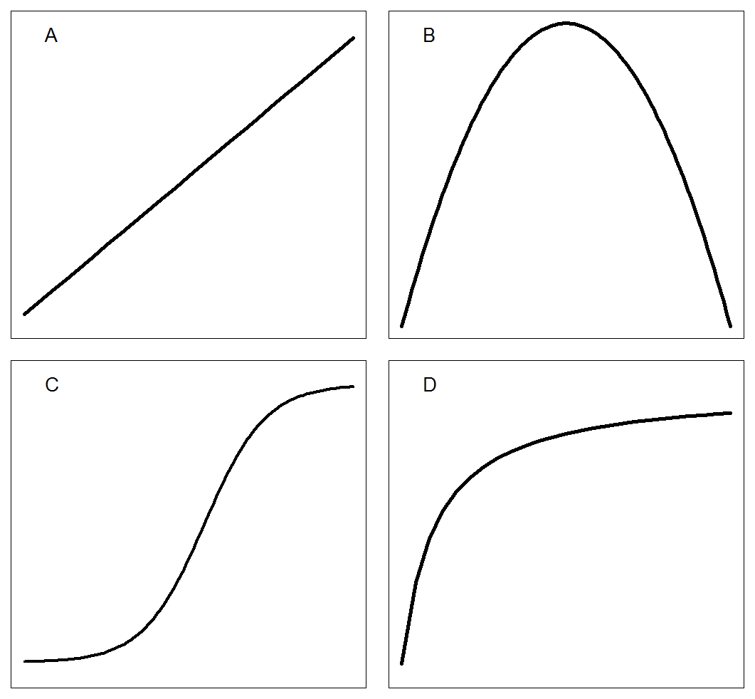Figure 1. Common regressions curves used in crop-weed relationships in additive design: A) Linear; B) Polynomial quadratic; C) Sigmoid; D) Rectangular hyperbola.

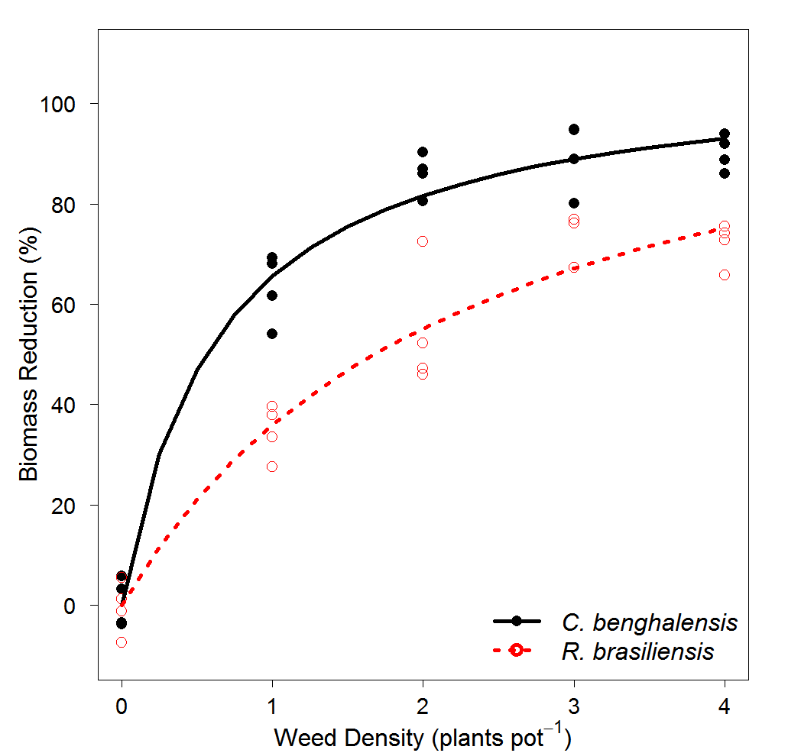

Figure 1. Relationship between maize biomass reduction (%) and weed density (plants pot-1) fitted with Cousens model. Red dotted lines represents *R. brasiliensis* and black solid line represents *C. benghalensis*. Biological model parameter estimates, *R. brasiliensis*: I= 51.7 (7.7) and A= 118.1 (14.6); *C. benghalensis*: I= 167.2 (29.8) and A= 108.1 (5.6).

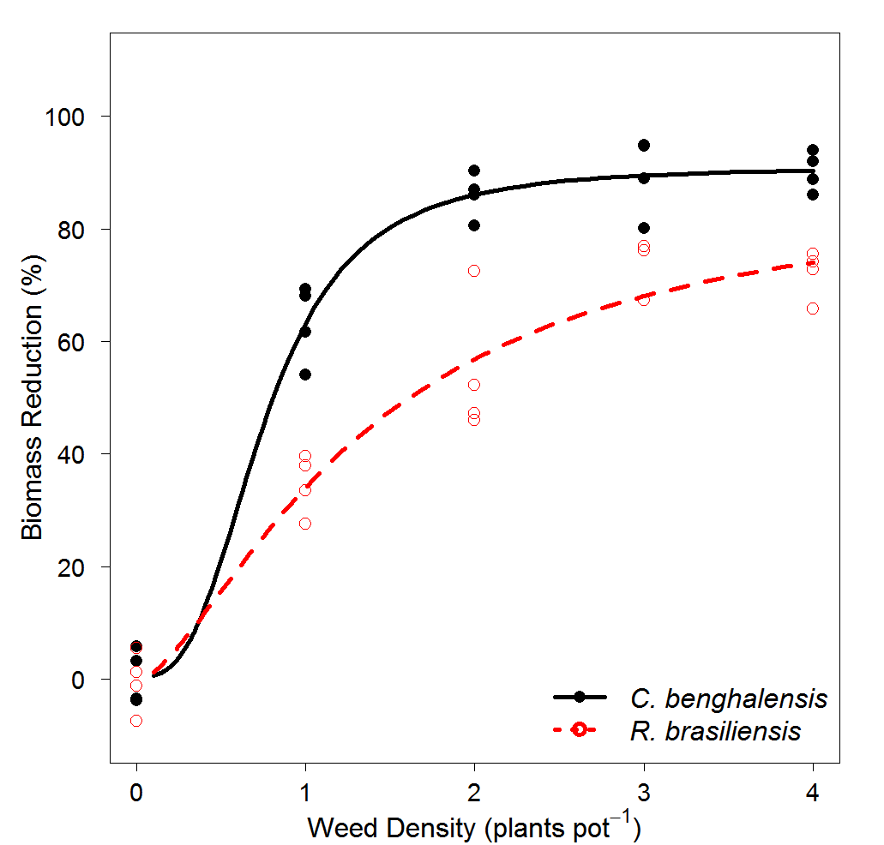

Figure 3. Relationship between maize biomass reduction (%) and weed density (plants pot-1) fitted with a logistic model. Red dotted lines represents *R. brasiliensis* and black solid line represents *C. benghalensis*. Biological model parameter estimates, *R. brasiliensis*: b=-1.5 (0.5), c=-0.4 (3.2), d= 91.0 (3.2), and e= 0.76 (0.09); *C. benghalensis*: b=-2.92 (1.6), c=0.5 (3.2), d= 88.1 (15.9), and e= 1.3 (0.4).

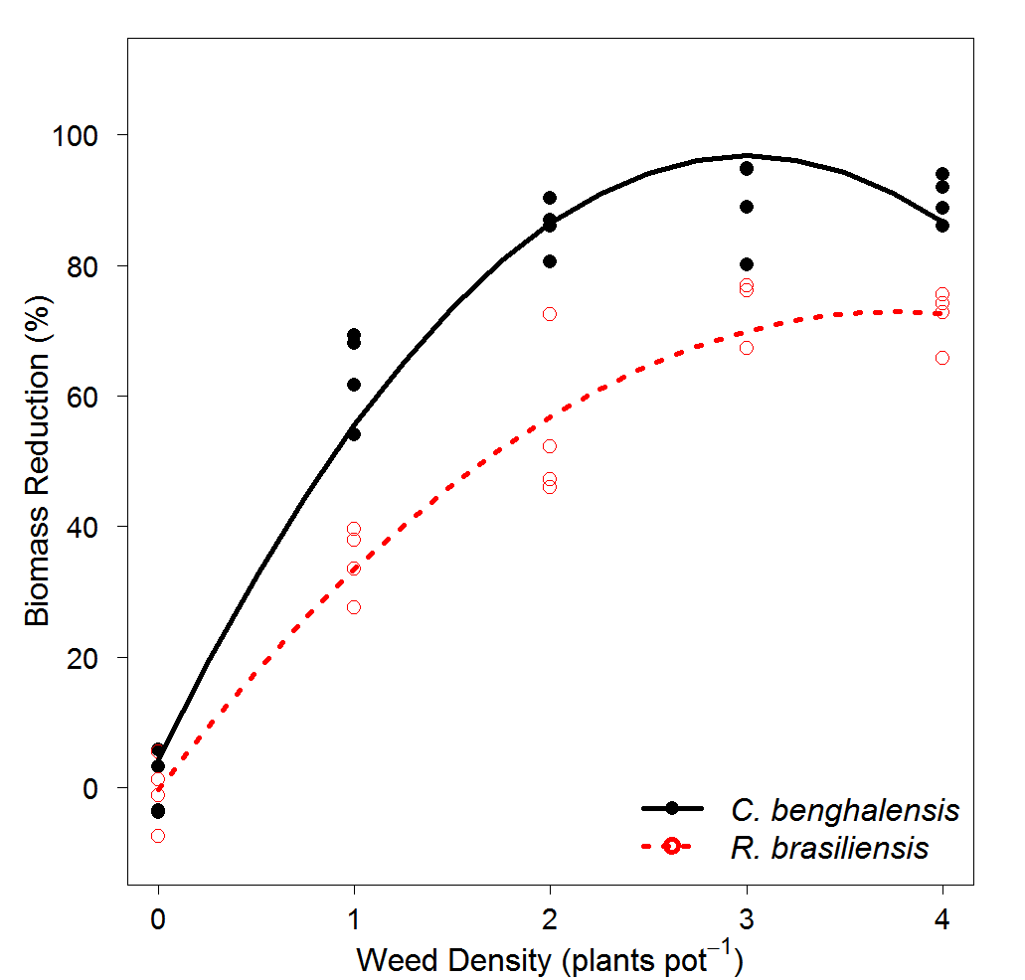

Figure 4. Relationship between maize biomass reduction (%) and weed density (plants pot-1) fitted with a polynomial quadratic model. Red dotted lines represents *R. brasiliensis* and black solid line represents *C. benghalensis*. There is no biological model parameters. *R. brasiliensis*: *YL*= 4.2+61.6x-10.3x2; *C. benghalensis*: YL= -0.3+38.9x-5.2x2

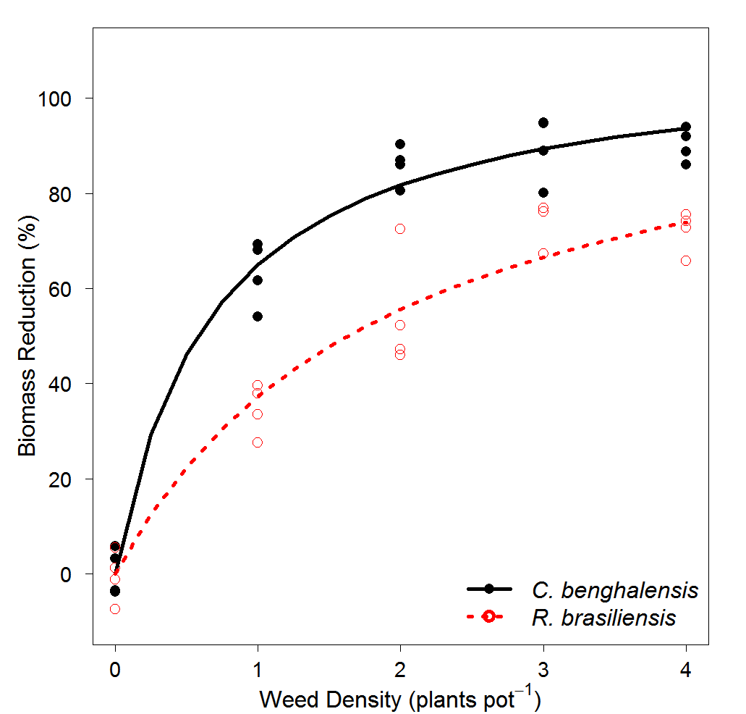

Figure 5. Relationship between maize biomass reduction (%) and weed density (plants pot-1) fitted with Cousens model. Red dotted lines represents *R. brasiliensis* and black solid line represents *C. benghalensis*. Biological model parameter estimates, *R. brasiliensis*: *I*= 56.4 (4.9) and *A*= 109.7 (5.2); *C. benghalensis*: I= 159.8 (25.4) and A= 109.7 (5.2).

Table 1. Maize biomass reduction model comparison among polynomial quadratic, logistic, and Cousens.

|  |  |  |  |  |  |
| --- | --- | --- | --- | --- | --- |
| Models | Species | Model Selection1 | Goodness of Fit2 | | |
| AIC | RMSE | ME | R2 |
| Polynomial quadratic | *C. benghalensis* | 281.8 | 6.7 | 0.96 | 0.95 |
|  | *R. brasiliensis* | 0.95 | 0.94 |
| Logistic | *C. benghalensis* | 271.3 | 5.7 | 0.89 | - |
|  | *R. brasiliensis* | 0.83 | - |
| Cousens | *C. benghalensis* | 268.3 | 6.1 | 0.97 | - |
|  | *R. brasiliensis* | 0.94 | - |

1Alkeike’s information criterion (AIC).

2Root mean square error (RMSE), model efficiency (ME), and R-squared (R2). R2 is not appropriated for nonlinear models (logistic and Cousens).

Table 2. Cousens model parameters estimates, standard error, t-value and P-value of maize biomass reduction (%) caused by competition of *R. brasiliensis* and *C. benghalensis*.

|  |  |  |  |  |  |  |
| --- | --- | --- | --- | --- | --- | --- |
| Parameters1 | Species | Estimate | Standard Error | t-value | P-value2 | |
|  |  | % | |  |  |  |
| *I* | *R. brasiliensis* | 51.7 | 7.7 | 6.6 | 9.66e-8 | *** |
| *C. benghalensis* | 167.2 | 29.8 | 5.6 | 2.35e-6 | *** |
| *A* | *R. brasiliensis* | 118.1 | 14.6 | 8.1 | 1.39e-9 | *** |
| *C. benghalensis* | 108.1 | 5.6 | 19.1 | < 2e-16 | *** |

1*I*: represents maize biomass reduction (%) per unit weed density as density approaches 0; *A*: represents maize biomass reduction (%) as density approaches ∞ (or maximum expected yield loss).

2If P<0.05, there is no lack of fit; If P>0.05, there is lack of fit. *** Significant at <0.01.

Table 3. Logistic model parameters estimates, standard error, t-value and P-value of maize biomass reduction (%) caused by competition of *R. brasiliensis* and *C. benghalensis*.

|  |  |  |  |  |  |  |
| --- | --- | --- | --- | --- | --- | --- |
| Parameters1 | Species | Estimate | Standard Error | t-value | P-value2 | |
|  |  | % | |  |  |  |
| *b* | *R. brasiliensis* | -1.5 | 0.5 | -2.8 | 0.008 | *** |
| *C. benghalensis* | -2.9 | 1.6 | -1.8 | 0.082 | * |
| *c* | *R. brasiliensis* | -0.4 | 3.21 | -0.1 | 0.903 | NS |
| *C. benghalensis* | 0.5 | 3.20 | 0.2 | 0.888 | NS |
| *d* | *R. brasiliensis* | 88.1 | 15.9 | 5.5 | 0.000 | *** |
| *C. benghalensis* | 91.0 | 3.9 | 22.8 | 0.000 | *** |
| *e* | *R. brasiliensis* | 1.34 | 0.4 | 3.7 | 0.000 | *** |
| *C. benghalensis* | 0.76 | 0.1 | 7.0 | 0.000 | *** |

1*b*: slope; *c*: lower limit (weed competition at low densities); d: upper limit (maximum expected maize biomass reduction, %); *e*: inflection point (weed density at maize biomass reduction is 50% relative to *d*.

2If P<0.05, there is no lack of fit; If P>0.05, there is lack of fit. *** Significant at 0.01; * Significant at 0.1; NS, not significant.

Table 4. Polynomial quadratic parameters estimates, standard error, t-value and P-value of maize biomass reduction (%) caused by competition of *R. brasiliensis* and *C. benghalensis*.

|  |  |  |  |  |  |  |
| --- | --- | --- | --- | --- | --- | --- |
| Parameters1 | Species | Estimate | Standard Error | t-value | P-value | |
|  |  | % | |  |  |  |
| *Intercept* | *R. brasiliensis* | -0.3 | 3.3 | -0.1 | 0.94 | NS |
| *C. benghalensis* | 4.2 | 3.6 | 1.2 | 0.26 | NS |
| *Slope* | *R. brasiliensis* | 38.9 | 3.9 | 10.1 | 1.39e-8 | *** |
| *C. benghalensis* | 61.6 | 4.3 | 14.5 | 5.59e-11 | *** |
| *Quadratic* | *R. brasiliensis* | -5.2 | 0.9 | -5.6 | 3.29e-5 | *** |
| *C. benghalensis* | -10.3 | 1.0 | -10.0 | 1.48e-8 | *** |

1*Intercept*: intercept at Y-value when density equals zero; Slope: the slope of the equation; *quadratic*: the quadratic term of the equation.

2If P<0.05, there is no lack of fit; If P>0.05, there is lack of fit. *** Significant at 0.01; * Significant at 0.1; NS, not significant.

Table 5. Nested model selection criteria and goodness of fit of Cousens model parameters I and A of maize biomass reduction (%) with *R. brasiliensis* and *C. benghalensi*s.

|  |  |  |  |  |  |  |  |
| --- | --- | --- | --- | --- | --- | --- | --- |
|  | Null hypothesis | Species | Model Selection1 | | | Goodnes of fit2 | |
| Models | F-test | | AIC | RSME | ME |
| F-value | P-value |
| Full model | Different I and A | *R. brasiliensis* | - | - | 268.2 | 6.1 | 0.97 |
| *C. benghalensis* | 0.94 |
| Reduced 1 | Similar I and A | *R. brasiliensis* | 57.858 | 5.687e-12 | 321.8 | 12.5 | 0.88 |
| *C. benghalensis* | 0.79 |
| Reduced 2 | Similar I but different A | *R. brasiliensis* | 26.031 | 1.1e-05 | 288.0 | 8.0 | 0.96 |
| *C. benghalensis* | 0.89 |
| Reduced 3 | Similar A but different I | *R. brasiliensis* | 0.4947 | 0.4864 | 266.8 | 6.1 | 0.98 |
| *C. benghalensis* | 0.94 |

1F-test model selection; P<0.05: significant different models; P>0.05: non-significant different models. Alkeike’s information criterion (AIC);

2Root mean square error (RMSE) and model efficiency (ME).

Table 6. Cousens model parameters estimates, standard error, t-value and P-value of maize biomass reduction (%) caused by competition of *R. brasiliensis* and *C. benghalensis*.

|  |  |  |  |  |  |  |  |  |
| --- | --- | --- | --- | --- | --- | --- | --- | --- |
| Parameters1 | Species | Estimate | Standard Error | t-value | | P-value | | |
|  |  | % | | |  | |  |  |
| I | *R. brasiliensis* | 56.4 | 7.7 | | 6.6 | | 2.45e-7 | *** |
| *C. benghalensis* | 159.9 | 29.8 | | 5.6 | | 9.31e-14 | *** |
| A | *R. brasiliensis* | 109.7 | 5.2 | | 20.9 | | <2e-16 | *** |
| *C. benghalensis* |

1 *I*: represents maize biomass reduction (%) per unit weed density as density approaches 0; *A*: represents maize biomass reduction (%) as density approaches ∞ (or maximum expected yield loss).

2If P<0.05, there is no lack of fit; If P>0.05, there is lack of fit. *** significant at <0.01.